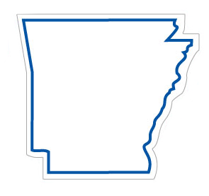
Arkansas….the Who, What, When, Where, Why
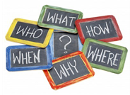
CAST:
MISS ARKANSAS (tiara and sash)
WHO (with Famous Arkansans cards)
WHAT
WHEN
WHERE (with Name that Place cards)
WHY

MISS ARKANSAS: (Miss Arkansas waves to the crowd.) Hello, I’m Miss Arkansas. Today we are going to learn about places and faces in Arkansas.
ALL: Places and Faces? Who, What, When, Where, Why?
MISS ARKANSAS: Arkansas officially became a state back in 1836. The 25th state of the 50 we know today. But, before Arkansas became a state, some very important men came exploring the land to see what there was to see.
ALL: Explorers? Who? Who? Who?
MISS ARKANSAS: Who? Well, men like Hernando De Soto, Marquette and Jolliet to name a few.
ALL: Oh, that’s “who”!
MISS ARKANSAS: Well, that’s some of the early explorers. Today, we are proud of many famous people who call Arkansas home.
ALL: Famous people? from Arkansas? Who? Who? Who?
MISS ARKANSAS: There are too many to mention them all, but we’ll choose a few to spotlight today. Here’s a little challenge! You will have to guess who each one is based on clues.
WHO: These three clues describe Famous Arkansan #1.
- Clue 1: I was born in Hope.
- Clue 2: I was the Governor of Arkansas.
- Clue 3: I served as President of the United States for two terms. There is a Presidential Library named in my honor.
Guess “who” I am?

ALL: Bill Clinton. That’s Who!
WHO: You are correct! (Reveal photo of Famous Arkansan #1.)
WHO: Here are three clues that describe Famous Arkansan #2.
- Clue 1: I was always very competitive.
- Clue 2: I took a risk and started my first store, The Ben Franklin Store, in Newport. I soon moved to Bentonville to start a new store with a different name.
- Clue 3: Today, consumers shop in my stores all over the world.
Guess “who” I am?
ALL: Sam Walton. That’s Who!
WHO: Exactly! (Reveal photo of Famous Arkansan #2.)
WHO: There are many more important notable actors, musicians, politicians, and businessmen who we could learn about, but we’re going to focus on a famous Arkansas lady now. Here are the clues for Famous Arkansan #3.
- Clue 1: I was born in Huttig.
- Clue 2: My husband and I published the Arkansas State Press.
- Clue 3: I helped mentor nine African American students as they entered an all-white school in Little Rock named Central High School.
Guess “who” I am?

ALL: Daisy Bates. That’s Who!

WHO: That’s right!(Reveal photo of Famous Arkansan #3.)

MISS ARKANSAS: So, that answers some of the “whos” when we talk about famous Arkansans. Some produced goods while others provided services. Now let’s move to “what”.

WHAT: “What” comes to people’s minds when they think about Arkansas?
ALL: What do people think about? You tell us! What? What? What?

WHAT: They think about the many natural resources… the lakes, the mountains, and the many agricultural crops grown in Arkansas.

ALL: We are the Natural State, of course!

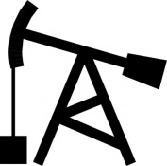
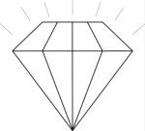
WHAT: Did you know that oil was discovered in the El Dorado area in 1921? Did you know that you can dig for diamonds at Crater of Diamonds State Park and keep what you find?

ALL: Oil and Diamonds! Wow!

WHAT: Did you know that there are festivals across our state celebrating special events? For instance, there is the Pink Tomato Festival, Spinach Festival, Picklefest, Ding Dong Days, Armadillo Festival, Whistlestop Festival, Ozark Folk Festival, and even a Mosquitofest.
ALL: Mosquitofest….Ouch!

MISS ARKANSAS: There is so much to learn, but it’s time to move to “when”.

WHEN: There are many special dates and events in Arkansas’ history.

ALL: What events? When did they happen? When? When? When?

WHEN: You like to shop. Right?

ALL: Sure!

WHEN: Long ago, before there were stores and malls and before Arkansas was even a state, people bartered for goods to satisfy their wants. In 1686, de Tonti established the Arkansas Post hoping to initiate trade with the American Indians.

ALL: What did they trade? Baseball cards and video games?

WHEN: Not exactly.

ALL: Well, what?

WHEN: They might trade animal furs, jewelry, food, natural medicines or bear oil.
ALL: We still want some of those goods in our marketplace today, and much, much more!

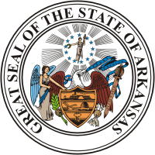
WHEN: Way back in 1803, France sold all of Louisiana and what is today Arkansas to the United States in a transaction called the Louisiana Purchase. There is a state park and a national historic landmark that tells all about it. We already know when Arkansas became an official state. Right?

ALL: In 1836, Arkansas, the Great, became the 25th state.

WHEN: In 1862, major battles of the Civil War occurred in our state at Pea Ridge and Prairie Grove. The state Capitol was completed in 1915. In 1927, the Mississippi River flooded about one fifth of the state, destroying homes, businesses, crops and lives.

ALL: Whew! That was a long time ago.

WHEN: Fast forward to 2011…Crystal Bridges Museum of Modern Art opened in Bentonville and is bringing many tourists to our state. There are many, many more important dates in Arkansas’s history…some happy, some sad but all contribute to our state’s history.

ALL: Dates in history make important events to remember. All the choices that have been made in our state’s history had costs and benefits, and the choices we make today do, too.

MISS ARKANSAS: Now we are to the “where.” We know there are many great places to visit in Arkansas. Once again, we’ll spotlight a few.

WHERE: Arkansas has many famous attractions. Let’s play a little game called “Name that Place.”
ALL: Ready! Where? Where? Where?
WHERE: This is one of the state’s top tourist destinations. It is a city filled with many special sites such as Garvan Woodland Gardens, Bathhouse Row, and Magic Springs to name a few. Name that Place.
ALL: Hot Springs….that’s “where!”
WHERE: (Reveal answer.) You are correct! Here’s another. If you want to visit some cool caverns near Mt. View and see bats, stalagmites and stalactites, this is the place for you. Name that place.
ALL: Blanchard Springs Cavern…that’s “where!”
WHERE: (Reveal answer.) That’s right! From Newburg to Stamps and from Earle to Waldron, there are many sites to visit.

ALL: North, South, East, West, Arkansas places are the best.

MISS ARKANSAS: Right again! Now, let’s move to “why.”

WHY: Why should we learn about Arkansas?

ALL: You tell us! Why? Why? Why?

WHY: Knowing about decisions made throughout Arkansas’ history and being aware of the natural resources and human resources that make our state wonderful today help build our human capital. We are training our brains! The more we know, the more we can share with others and make a difference for the future.

MISS ARKANSAS: I’d like to take this opportunity to say, “Congratulations!” You have certainly learned a lot about Arkansas and passed the Who, What, When, Where and Why test!
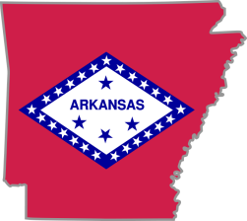
ALL: Arkansas…the Who, What, When, Where and Why!

SOURCES:

Arkansas the Natural State http://www.arkansas.com
Encyclopedia of Arkansas http://www.encyclopediaofarkansas.net
The Arkansas Handbook by Diann Sutherlin, 1996. Fly-By-Night Press, Little Rock.

