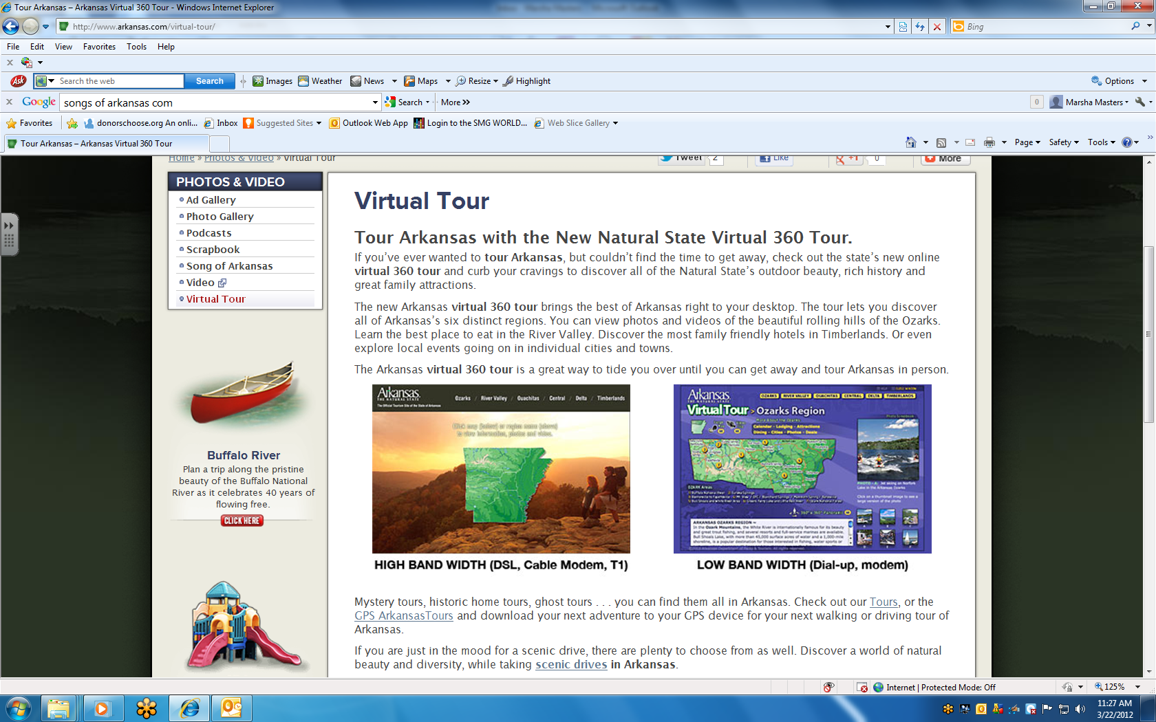
GREAT ARKANSAS VIRTUAL TOURS: http://www.arkansas.com/virtual-tour/

